Manufacturability Estimates INSM1

2024-05-17

## Analysis summary for FAT simulations based on Class 1 Manufacturability Design (D198599)

## FAT criteria were applied as follows:

Test and Reference Slides were compared to an absolute range of 2 to 3 Signal Intensity , as well as a maximum allowable delta (Test-Ref) of 0.5 points.  
Test SI Acceptable: 2 to 3  
Test Background Acceptable: <= 0.5  
Control SI Acceptable: 2 to 3  
Control Background Acceptable: <= 0.5

## Result Classification:

FAT results were classified as Invalid for any instance with the Control slide failing for staining. Invalid is not considered a passing result for manufacturability estimates of First Time Pass Rate (FTPR), as it would require a rerun at minimum and potentially trigger the LEE/NC process.

For all comparisons, the maximum acceptable difference in SI between test and reference is 0.5 points. This data set did not include any failing NRC slides, so NRC was assumed to be a negligible contributor to fail rate and was not explicitly modeled here.

## All Reader Combined FAT Result

| FAT_Result | Frequency | Percent |
| --- | --- | --- |
| Fail | 12 | 2.16 |
| Invalid | 21 | 3.78 |
| Pass | 522 | 94.05 |

## All Reader Combined FAT FTPR

| FAT_FTPR | Frequency | Percent |
| --- | --- | --- |
| Pass | 522 | 94.05 |
| Rerurn/LEE | 33 | 5.95 |

## FAT Result by Reader

| Reader |  | FAT_Result | | | |
| --- | --- | --- | --- | --- | --- |
| Fail | Invalid | Pass | Total |
| 1 | Count | 3 | 2 | 180 | 185 |
| Row pct | 1.6% | 1.1% | 97.3% |  |
| 2 | Count | 3 | 2 | 180 | 185 |
| Row pct | 1.6% | 1.1% | 97.3% |  |
| 3 | Count | 6 | 17 | 162 | 185 |
| Row pct | 3.2% | 9.2% | 87.6% |  |
| Total | Count | 12 | 21 | 522 | 555 |

## FAT FTPR by Reader

| Reader |  | FAT_FTPR | | |
| --- | --- | --- | --- | --- |
| Pass | Rerurn/LEE | Total |
| 1 | Count | 180 | 5 | 185 |
| Row pct | 97.3% | 2.7% |  |
| 2 | Count | 180 | 5 | 185 |
| Row pct | 97.3% | 2.7% |  |
| 3 | Count | 162 | 23 | 185 |
| Row pct | 87.6% | 12.4% |  |
| Total | Count | 522 | 33 | 555 |

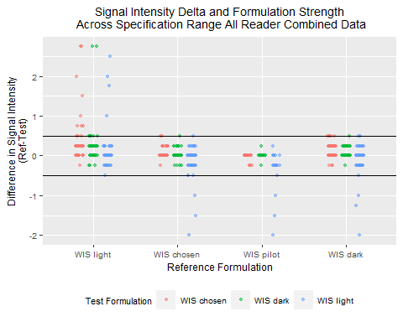

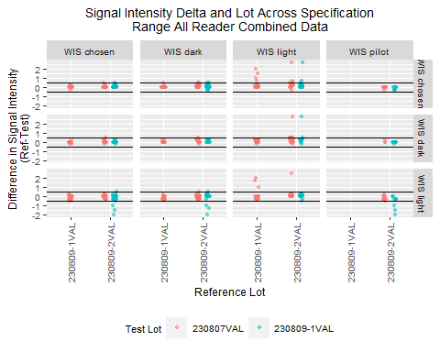

## Reader 1 Analysis

| FAT_Result | Frequency | Percent |
| --- | --- | --- |
| Fail | 3 | 1.62 |
| Invalid | 2 | 1.08 |
| Pass | 180 | 97.30 |

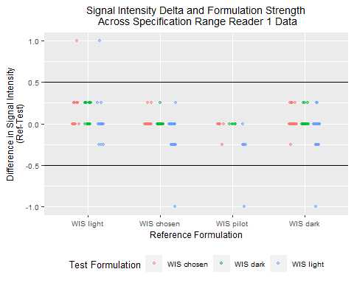

## Reader 2 Analysis

| FAT_Result | Frequency | Percent |
| --- | --- | --- |
| Fail | 3 | 1.62 |
| Invalid | 2 | 1.08 |
| Pass | 180 | 97.30 |

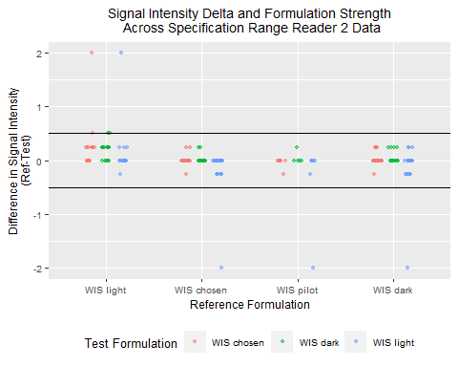

## Reader 3 Analysis

| FAT_Result | Frequency | Percent |
| --- | --- | --- |
| Fail | 6 | 3.24 |
| Invalid | 17 | 9.19 |
| Pass | 162 | 87.57 |

